Lower Merion School District

301 East Montgomery Avenue ♦ Ardmore, PA 19003-3399

Phone: 610-645-1912 ♦ Fax: 610-645-9531 ♦ www.lmsd.org

January 11, 2019

Dear Families of Grade 5 Level Math Students:

At the end of grade 4, multiple mathematics performance and achievement data sets are collected and reviewed on your child. Based upon the review of all the data, your child’s fifth grade mathematics placement was determined.

The grade level math program is providing your child the opportunity to fully develop and understand the foundational skills necessary to be successful in higher level math. Every effort is being made to make sure your child is appropriately challenged, and supports are provided when necessary. Also, the progress of all children is being closely monitored throughout the year to ensure that their math placement is appropriate when they enter grade 6. Although all grade level students are no longer being assessed at the end of grade 5, students who have consistently demonstrated that they can apply and extend math content, knowledge and processes will be considered for reassessment. The chart below explains the current progression of math courses beginning in grade 4 and the additional opportunities for math acceleration.

The criteria used to determine which students qualify for reassessment at the end of grade 5 for possible placement in Math 7/8 in grade 6 is fully explained on the reverse side of this letter. Please feel free to contact me if you have any questions.

Sincerely,

Na

Nancy Acconciamessa
Supervisor of Elementary STEM

M

a

t

h

4

M

a

t

h

5

M

a

t

h

6

E

l

i

g

i

b

l

e

S

c

r

e

e

n

E

l

i

g

i

b

l

e

S

c

r

e

e

n

M

a

t

h

7

/

8

S

u

m

m

e

r

B

r

i

d

g

e

6

M

a

t

h

6

E

l

i

g

i

b

l

e

S

c

r

e

e

n

I

n

t

e

g

r

a

t

e

d

M

a

t

h

1

S

u

m

m

e

r

B

r

i

d

g

e

8

M

a

t

h

7

M

a

t

h

8

I

n

t

e

g

r

a

t

e

d

M

a

t

h

2

I

n

t

e

g

r

a

t

e

d

M

a

t

h

3

E

l

i

g

i

b

l

e

S

c

r

e

e

n

M

a

t

h

E

l

e

c

t

i

v

e

s

Summer
Bridge 5

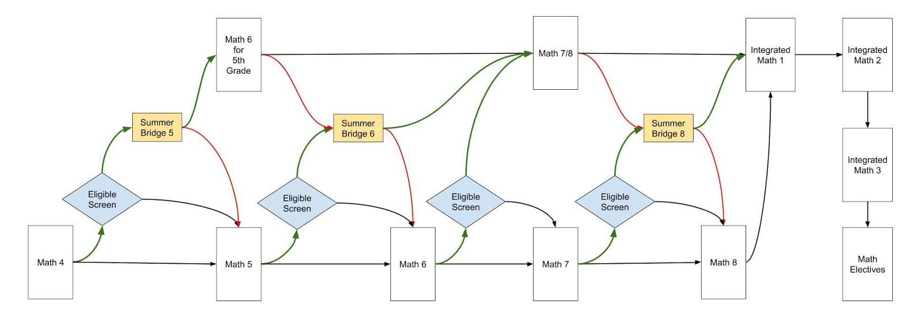

Approved by the School of Board Directors in October, 2018

Criteria for Reassessment at the End of Grade 5

Below is an explanation of the district-wide process and criteria for reassessment at the end of grade 5. All of our mathematics courses are rigorous and reinforce our commitment to high achievement for all students.

- The following criteria will be used to determine which students will be reassessed at the end of grade 5 for possible placement into the Math 7/8 course in grade 6.

- A score of Advanced on each District benchmark assessment. Benchmarks are used as "checkpoints" to monitor progress toward meeting performance goals within and across grade levels. There are three District-made benchmark assessments administered for the year to assess where students are in regards to the grade level content addressed up to that point in time.

You will receive notification in early June specifying if your child qualifies for reassessment.

Should your child qualify to enter the Math 7/8 program in grade six, he/she will be required to complete a summer bridge program. This is to ensure that he/she is fully prepared to enter Math 7/8 by addressing the Math 6 skills and competencies that will be prerequisites for this course.

If you have any questions, please contact the Math Office at 610-645-1912. Thank you.

