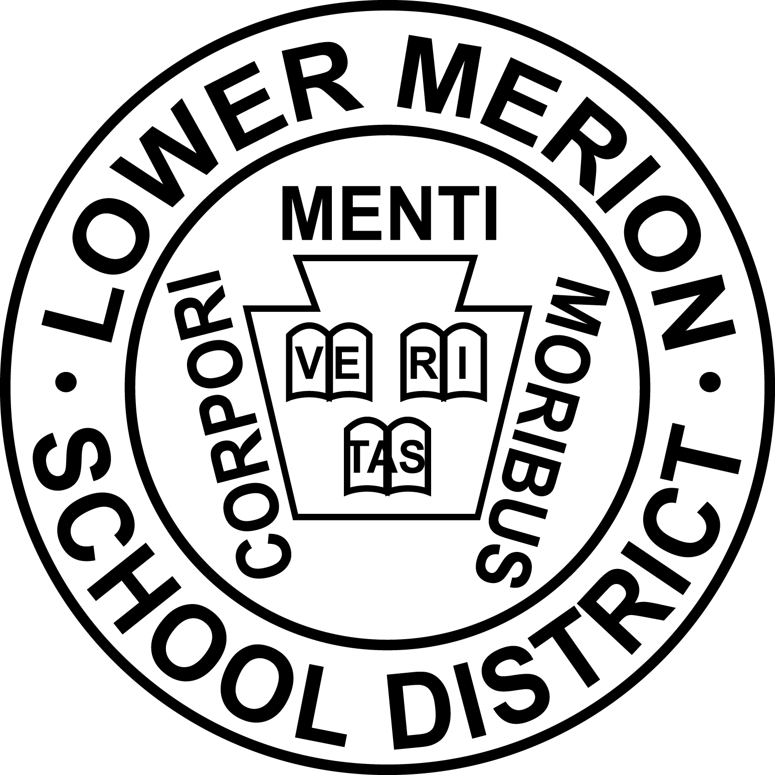
Lower Merion School District
CARE
SWOT – Strengths, Weaknesses, Opportunities and Threats
Strengths  What does the system do well? What unique system resources can you draw on? What do others see as the system’s strengths? | Evidence

Weaknesses  What could the system improve? Where does the system have fewer resources than others? What are others likely to see as weaknesses? | Evidence

Opportunities  What opportunities are open to the system? What trends could you take advantage of? How can you turn your strengths into opportunities? | Evidence

Threats  What threats could harm the system? What is your competition doing? What threats do the system’s weaknesses expose you to? | Evidence
Please return completed form to Dr. Marseille’s secretary, Esther Novak, at novake@lmsd.org

